COA LAB -3

1. Write a program in assembly language to perform subtraction of 8-bit data

Code:

org 100h

num1 db 39h

num2 db 18h

start:

mov al,num1 ;move num1 to the AL register sub al,num2 ;subtract the second number with AL

mov bl,al ;

convert the upper nibble(4 bits) of AL to characters

mov ah,al

and ah,0F0h ;mask the lower nibble

shr ah,4

add ah,30h ;convert the ASCHII digit (0-9) cmp ah,39h

jle print_first_digit

add ah,7 ;convert to ASCHII letter(A-F) if necessary

print_first_digit:

mov dl,ah ;move the first digit to DL for printing

mov ah,02h ;BIOS interrupt to display charater

int 21h

;convert the lower nibble (4 bits) of AL to characters

mov ah,bl

and ah,0Fh ;mask the upper nibble

add ah,30h

cmp ah,39h

jle print_second_digit

add ah,7

print_second_digit:

mov dl,ah

mov ah,02h

int 21h

;End the program

mov ah,4Ch

int 21h

ret

Output: 21

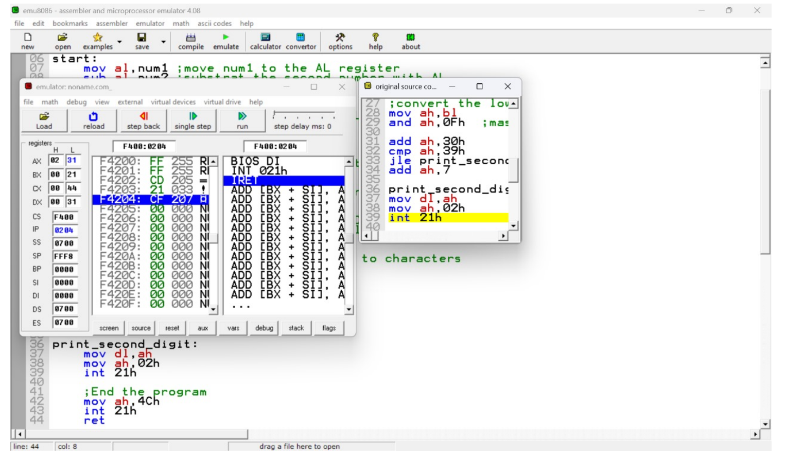

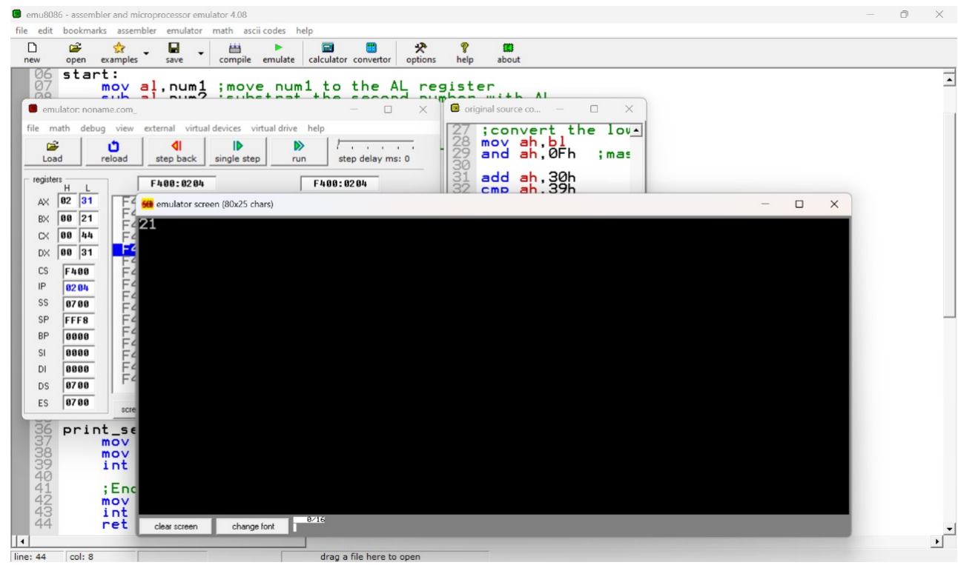

Practice set:

1. Write an assembly language program to perform subtraction of 16-bit data.

org 100h

num1 dw 5743h ; First 16-bit number num2 dw 1567h ; Second 16-bit number start:

; Load the lower bytes of num1 and num2

mov ax, num1 ; Load num1 into AX (AX = 1234h)

sub ax, num2 ; Add num2 to AX (AX = AX + num2)

; Store the result in BX for later use

mov bx, ax ; Copy AX to BX

; Convert upper byte (high 8 bits) to ASCII and display

mov al, ah ; Move the high byte of AX to AL and al, 0F0h ; Mask the lower nibble shr al, 4 ; Shift right to get the upper nibble

add al, 30h ; Convert to ASCII digit

cmp al, 39h ; Compare with ASCII value of '9'

jle print_first_digit

add al, 7 ; Convert to ASCII letter if needed

print_first_digit:

mov dl, al ; Move AL to DL for printing mov ah, 02h ; BIOS interrupt to display character

int 21h

; Convert lower nibble of the high byte to ASCII and display

mov al, bh ; Move the high byte of BX to AL again

and al, 0Fh ; Mask the upper nibble

add al, 30h ; Convert to ASCII digit

cmp al, 39h ; Compare with ASCII value of '9' jle print_second_digit add al, 7 ; Convert to ASCII letter if needed print_second_digit: mov dl, al ; Move AL to DL for printing mov ah, 02h ; BIOS interrupt to display character int 21h ; Convert upper nibble of the low byte to ASCII and display

mov al, bl ; Move the low byte of BX to AL and al, 0F0h ; Mask the lower nibble

shr al, 4 ; Shift right to get the upper nibble

add al, 30h ;

Convert to ASCII digit cmp

al, 39h ; Compare with ASCII value of '9' jle print_third_digit

add al, 7 ; Convert to ASCII letter if needed

print_third_digit:

mov dl, al ; Move AL to DL for printing mov ah, 02h ; BIOS interrupt to display character

int 21h

; Convert lower nibble of the low byte to ASCII

and display

mov al, bl ; Move the low byte of BX to AL and al, 0Fh ; Mask the upper nibble

add al, 30h ; Convert to ASCII digit cmp al, 39h ; Compare with ASCII value of '9' jle print_fourth_digit

add al, 7 ; Convert to ASCII letter if needed

print_fourth_digit:

mov dl, al ;

Move AL to DL for printing

mov ah, 02h ; BIOS interrupt to display character

int 21h

; Terminate the program

mov ah, 4Ch

int 21h

Output: 41DC

